NATIONAL UNIVERSITY OF ARCHITECTURE AND CONSTRUCTION OF ARMENIA
SAMPLE 5 OF THE INTRA-UNIVERSITY EXAM SUBJECT “TEST OF ASSESSING KNOWLEDGE AND CREATIVE ABILITIES” (AKCA) FOR THE ADMISSION FOR FULL-TIME STUDIES OF THE SPECIALTY “073101.00.6 – ARCHITECTURE” FOR 2026–2027 ACADEMIC YEAR

- Axonometry, sections, cuts, projections

Given are two projections of a solid. Construct the missing projection (left-side view), the rectangular isometric axonometric drawing, and all necessary sectional views.
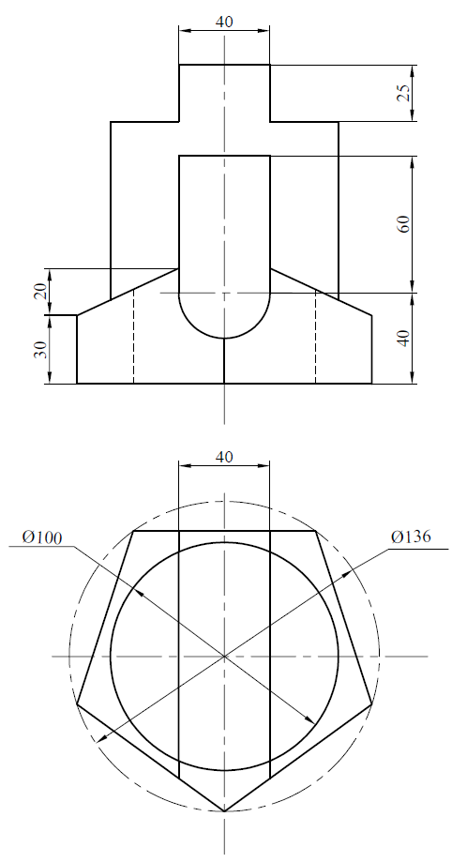
- Coupling

Construct a figure composed of line segments and circular arcs that satisfies the given conditions (dimensions and tangencies). (The small circles indicate the tangency points of two lines.) Add dimensions and preserve all construction lines.
