WP6 – Dissemination and exploitation
Duration: |  |  | M1 – M36 | Lead Beneficiary: |  |  |  |  | 14- YSU
Objectives
List the specific objectives to which this work package is linked.
Awareness raising on ESD for the target groups, project visibility, MA degree promotion.
Accessible website and electronic materials for people with visual and hearing impairments should be developed, as an example to later be replicated by AM HEIs. Bridge of Hope will support the YSU in this task.
Activities (what, how, where) and division of work
Task No  (continuo us  numberin g linked to WP) | Task Name |  |  |  |  | Description |  |  |  | Participants |  |  | In-kind Contributions and Subcontracting  (Yes/No and which)
 |  |  |  |  |  |  |  |  |  | Name |  | Role  (COO, BEN, AE, AP,  OTHER)
T6.1 | COMMS strategy and Action plan |  |  |  |  | The WP leader will develop the Communication and dissemination strategy and the Action plan, which will comprise of target groups, the identity of the project and the brand, online communication channels and offline materials, articles, presentations, reports etc. The strategy and the action plan will address the networking, events, media relationships and other relevant information to ensure wider national and international dissemination, awareness raising and the concrete plan of public consultations. |  |  |  | YSU  All BEN |  | BEN
T6.2 | Project web site |  |  |  |  | Development & regular update of Project Web-site as a platform for e-presentation of the project, external&internal |  |  |  | EIU and BOH  All BEN |  | BEN | Subcontracting: project web-site design,
 |  |  |  |  |  | dissemination & efficient communication. It will include the short links to the project communication and collaboration platform, download area. The parties will agree on the protocol for its regular-update and maintenance. |  |  |  |  |  |  | technical and security maintenance  Universal design should be ensured
T6.3 | Project information materials |  |  |  |  | Development & dissemination of Project`s Materials including a comprehensive set of project marketing package, including project logo, posters, leaflets, brochures, standard press releases etc. |  |  |  | NUACA and YSU  All BEN |  | BEN
T6.4 | Project Public dissemination and awareness raising events |  |  |  |  | Number of webinars will be organized during the project implementation to ensure continuous visibility of the project, awareness raising on the theme. The institutional consultations and events will also be part of the dissemination strategy and action plan. |  |  |  | YSU  All BEN |  | BEN
T6.5 | Final dissemination conference in  Yerevan and Press Conference  (Armenia) |  |  |  |  | During the dissemination conference the major deliverables of the project will be presented to stakeholders. During the forum though panel sessions and group discussions the project team will facilitate a larger dissemination and promote the integration of green skills in other subjects also and will promote the need for redesigning the National Qualification Framework to accommodate green skills and competences. |  |  |  | YSU  All BEN |  | BEN | 6.5. Subcontracting for printing and publishing: final conference (EIU)
Milestone No  (continuous numbering not linked to WP) |  | Milestone Name |  |  | Work Package No |  | Lead Beneficiary | Description |  |  |  | Due Date  (month number) | Means of Verification
MS11 |  | Project Website (Accessible for the Visually Impaired people) |  |  | 6 |  | YSU | The project website will not only serve for disseminating project information, but also will serve as a resource centre for the green educational content and material, research papers etc. All the educational programs and modules will be uploaded in the project website with full and open access. The website will be accessible for the visually impaired people and the idea of accessibility will also be promoted during the project implementation. |  |  |  | M3 | Functioning website
Deliverable No  (continuous numbering linked to WP) |  | Deliverable Name |  |  | Work Package No |  | Lead Beneficiary | Type |  |  | Dissemination Level | Due Date  (month number) | Description  (including format and language)
D6.1 |  | COMMS strategy  and action plan |  |  | 6 |  | YSU | [R —  Document, report] |  |  | [SEN -  Sensitive] | M3 | Electronic, English,  Armenian
D6.2 |  | Promotional materials |  |  | 6 |  | NUACA | [R —  Document, report] |  |  | [SEN -  Sensitive] | M3 | Electronic, English, Armenian
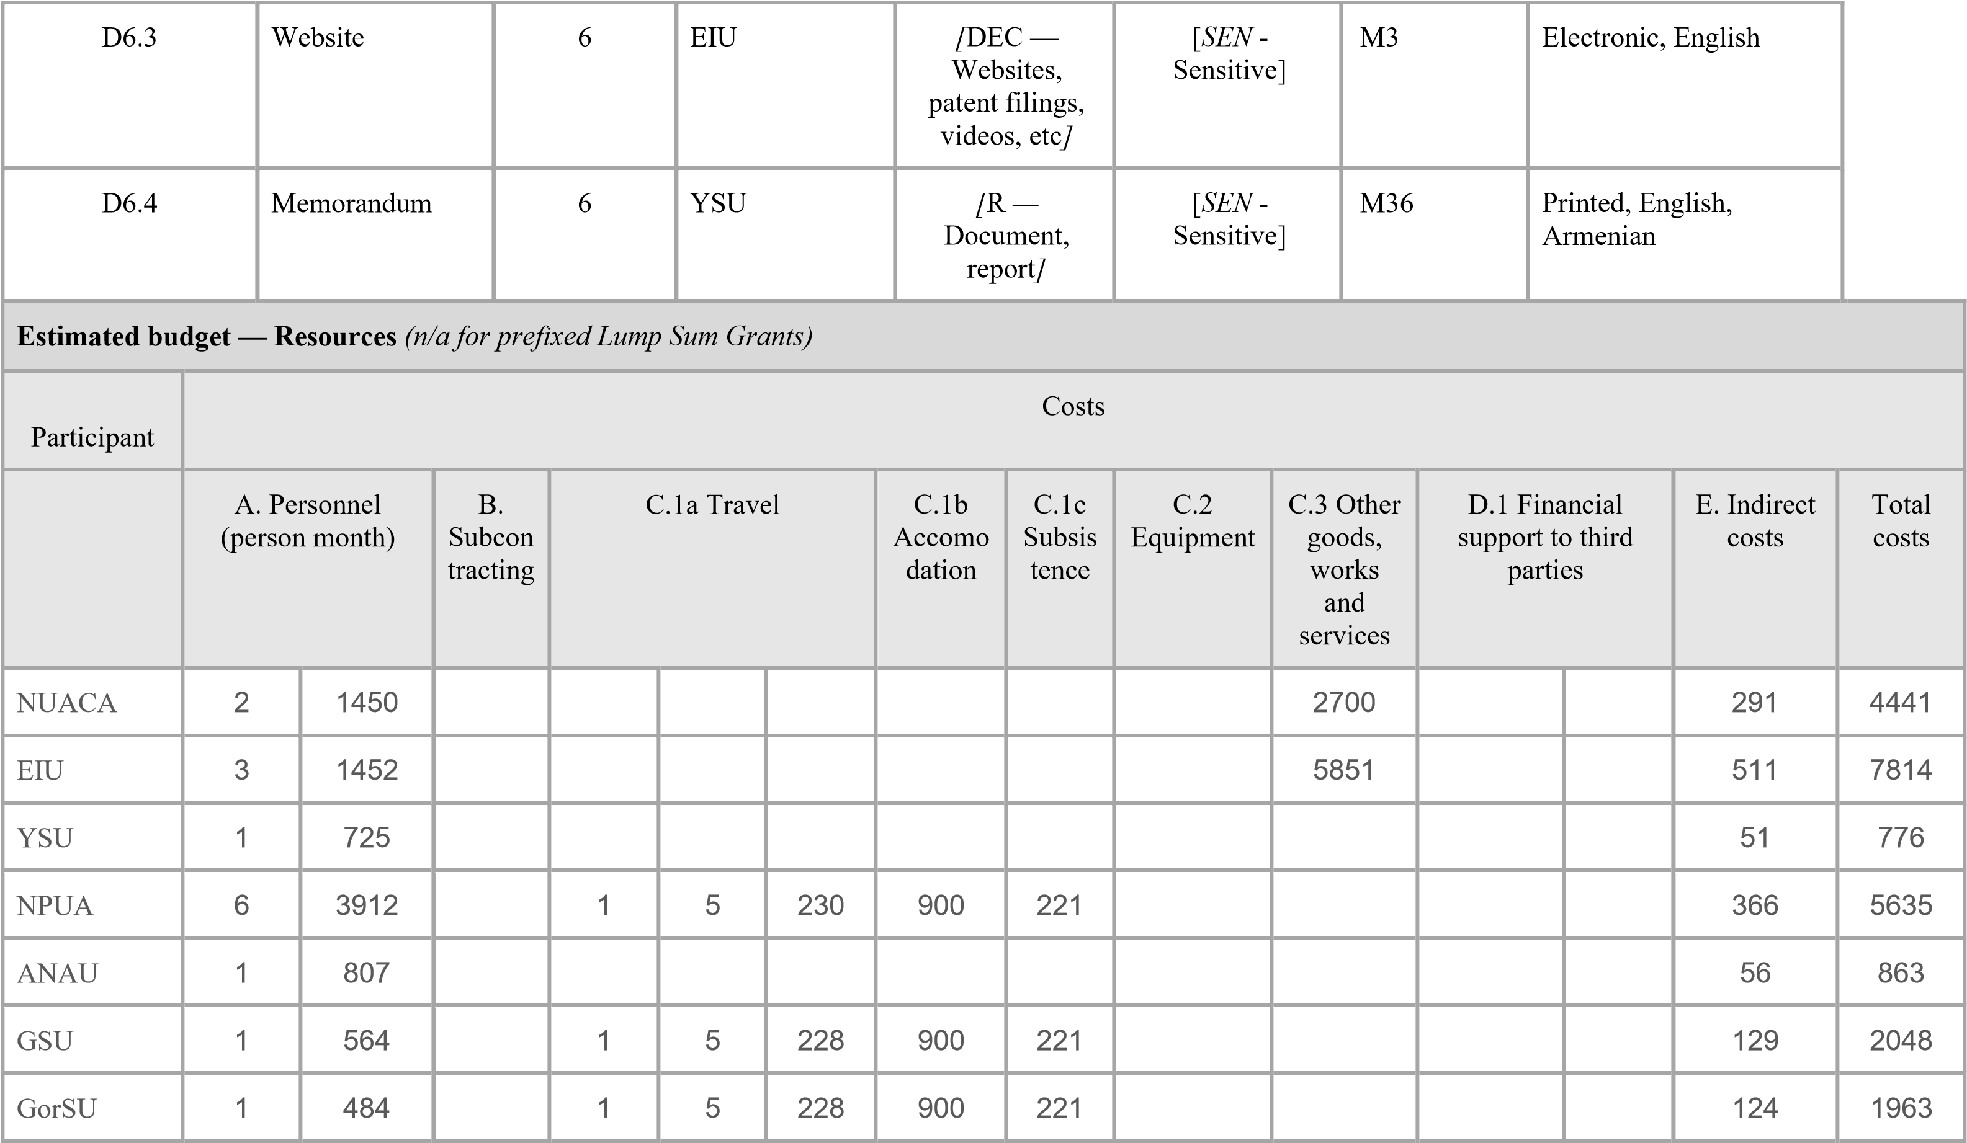
ASUE | 1 | 484 |  |  |  |  |  |  |  |  |  |  | 34 | 518
UFAR
ANQA
MESCS
ESN
BOH | 3 | 1595 |  |  |  |  |  |  |  |  |  |  | 112 | 1707
UCP |  |  |  | 1 | 3 | 1720 | 1242 | 942 |  |  |  |  | 273 | 4181
JU |  |  |  | 1 | 3 | 927 | 1242 | 942 |  |  |  |  | 216 | 3331
MRU |  |  |  | 1 | 3 | 927 | 1242 | 942 |  |  |  |  | 216 | 3331
IHU |  |  |  | 1 | 3 | 796 | 1242 | 942 |  |  |  |  | 208 | 3192
Total | 19 | 11473 |  | 7 | 27 | 5056 | 7668 | 4431 |  | 8551 |  |  | 2587 | 39800
For certain Lump Sum Grants, see detailed budget table/calculator (annex 1 to Part B; see Portal Reference Documents).

NUACA | 34 | 22024 |  |  |  |  |  |  |  | 3609 |  |  | 1794 | 27427
EIU | 27 | 17169 |  |  |  |  |  |  |  | 1809 |  |  | 1328 | 20306
YSU | 11 | 8549 |  |  |  |  |  |  |  |  |  |  | 598 | 9147
NPUA | 15 | 10435 |  |  |  |  |  |  |  |  |  |  | 731 | 11166
ANAU | 11 | 8148 |  |  |  |  |  |  |  |  |  |  | 570 | 8718
GSU | 11 | 7662 |  |  |  |  |  |  |  |  |  |  | 536 | 8198
GorSU | 12 | 7257 |  |  |  |  |  |  |  |  |  |  | 506 | 7763
ASUE | 20 | 10073 |  |  |  |  |  |  |  |  |  |  | 705 | 10778
UFAR | 9 | 11290 |  |  |  |  |  |  |  |  |  |  | 790 | 12080
ANQA | 7 | 7098 |  |  |  |  |  |  |  |  |  |  | 499 | 7597
MESCS | 12 | 7257 |  |  |  |  |  |  |  |  |  |  | 508 | 7765
ESN | 6 | 2179 |  |  |  |  |  |  |  |  |  |  | 152 | 2331
BOH | 4 | 2160 |  |  |  |  |  |  |  |  |  |  | 151 | 2311
UCP | 5 | 10966 |  |  |  |  |  |  |  |  |  |  | 768 | 11734
JU | 5 | 5871 |  |  |  |  |  |  |  |  |  |  | 411 | 6282
MRU | 5 | 5871 |  |  |  |  |  |  |  |  |  |  | 411 | 6282
IHU | 5 | 10645 |  |  |  |  |  |  |  |  |  |  | 745 | 11390
Total | 199 | 154654 |  |  |  |  |  |  |  | 5418 |  |  | 11203 | 171275
For certain Lump Sum Grants, see detailed budget table/calculator (annex 1 to Part B; see Portal Reference Documents).

